**Project: Telco Customer Churn**

DSC630_Predective_Analytics

Name: Bhargava Gaggainpali

**Final Project – Technical Report**

**Introduction**

**Background:**

Customer churn is a major problem and one of the most important concerns for every company. Retaining an existing customer is many times more effective thanks gaining new customers. Generally, people only switch to a different company only when the service is not to the level of expectation in one or the other factor when compared to competitors, more than getting attracted to the specials and offers which are offered by the other companies. As the number of peoples who use a phone or a telecom product does not increase in huge volume, any company looking to improve the profits is trying to attract other company customers. At the same time retaining existing customers is very important. As retaining a current customer is ten times more productive than gaining a new one.

**Problem Statement:**

As customer churn directly effects the revenues of the companies, companies are seeking to develop means to predict potential customer to churn. Therefore, finding factors that increase customer churn is important to take necessary actions to reduce this churn and retain the customers.

**Scope:**

Scope of the project is to use the sample dataset from Kaggle, which shows several categories of customers and also some influencing factors causing the customer churn in the telecom industry to perform customer segmentation and identify a pattern which influence the customer churn. Implement supervised machine learning process to achieve the goal.

**Document Overview:**

Detail all the steps which are followed to find the factors which are influencing the customer churn in the telecom industry. Which includes the source of the data, tools used to access data, processing mechanism to achieve the goal. Include the validation process to make sure the process is not biased.

**Preliminary Requirement**

**Technical Approach:**

Technical approach of performing Exploratory data analysis as the first step and disregard the non-relevant data and apply supervised machine learning algorithms to fit the model and validate the model by using confusion matrix.

**Data sources or plan for data:**

Data source from Kaggle. 7043 observations and 21 variables

[Telco Customer Churn | Kaggle](https://www.kaggle.com/blastchar/telco-customer-churn)

Given are list of the variables:

1. customerID
2. gender
3. SeniorCitizen
4. Partner
5. Dependents
6. tenure
7. PhoneService
8. MultipleLines
9. InternetService
10. OnlineSecurity
11. OnlineBackup
12. DeviceProtection
13. TechSupport
14. StreamingTV
15. StreamingMovies
16. Contract
17. PaperlessBilling
18. PaymentMethod
19. MonthlyCharges
20. TotalCharges
21. Churn

**Analysis:**

Will perform initial stats to check on the duplicate rows and null values to make sure the valid content of the data. Generate multiple charts on the variables to see the spread of the values in the variables. Perform Univariant analysis by using histograms and box plots. Perform Bivariant analysis by using correlation matrix and heat maps.

1. **Load the data from file into data frame.**

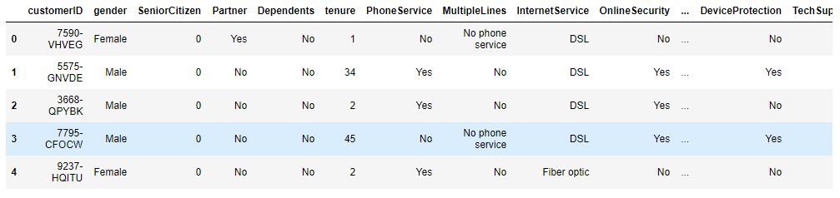

1. **Retrieve the number of variables and observations in the data frame.**

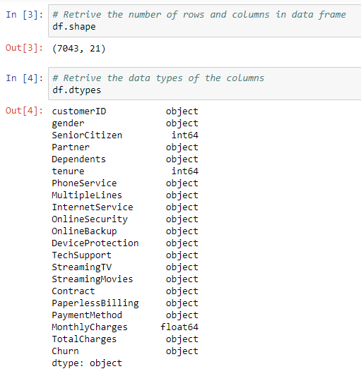

1. **Retrieve the stats of numeric fields.**

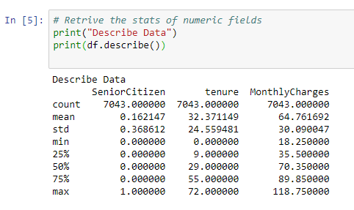

1. **Retrieve the stats of categorical Fields.**

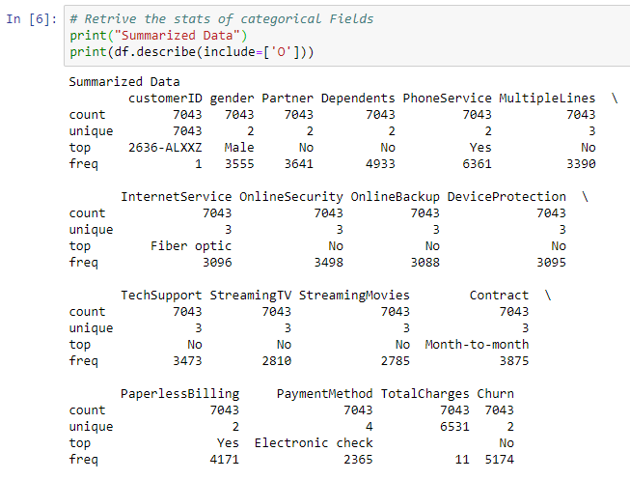

1. **Verify the data if there are any duplicates.**

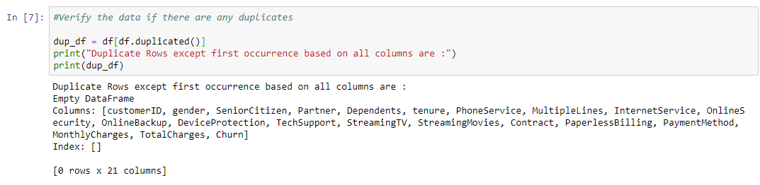

1. **Checking the count of null values in each column.**

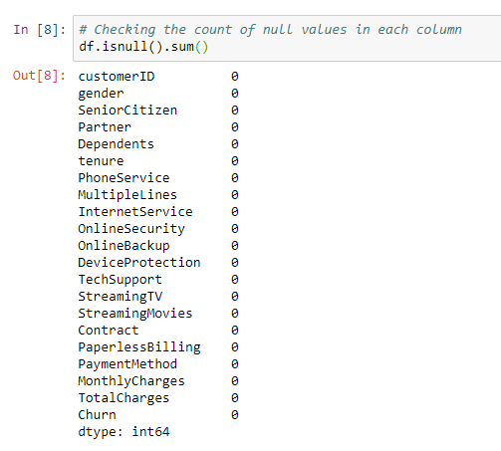

1. **Create charts-based Churn vs other Categorical Variables.**

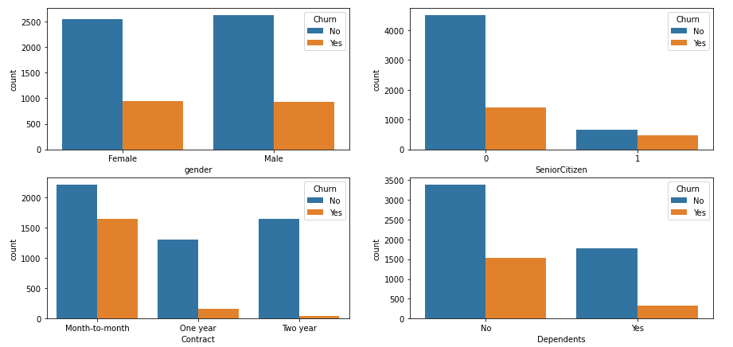

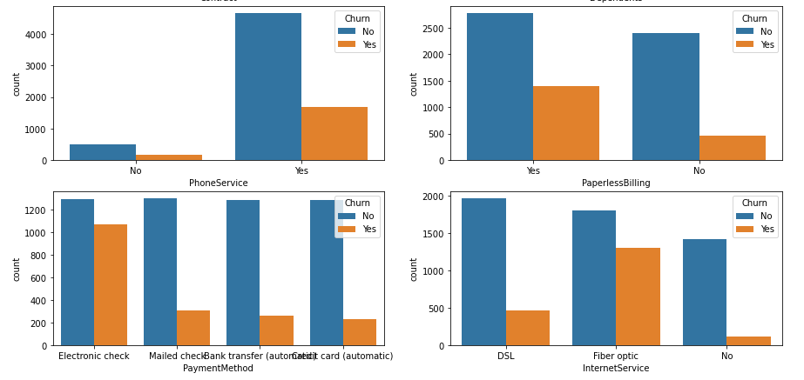

1. **Observations**

Gender vs Customer_Churn :

We do not see any difference in Male vs Female customers in terms of Customer Churn.

Contract_Type vs Customer_Churn :

'Month-on-month' type Contract has highest Customer Churn compared to other Contract Types.

Payment_Method vs Customer_Churn :

'Electronic Check' payment method has the highest Customer Churn.

Paperless_Billing vs Customer_Churn :

'Paperless Billing' has highest Customer Churn.

Type_Of_Internet_Service vs Customer_Churn :

'Fiber optic' Internet service has highest Customer Churn.

Phone_Service vs Customer_Churn :

People who has Phone Service has highese Customer Churn.

1. **Analyze Numerical Variables**

Observation is that, “tenure” variable has a better correlation with comparison to the output variable “churn”.

We built a histogram to see the spread of the data.

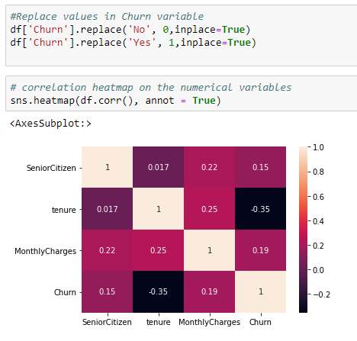

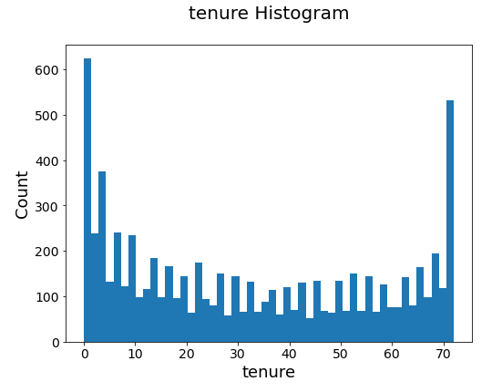

1. **Applied Encoding Method**

Applied Encoding method to convert Categorical variables to numerical values.

Applied Scalar method to convert the Numerical variable to reduce the value and maintain consistent value range.

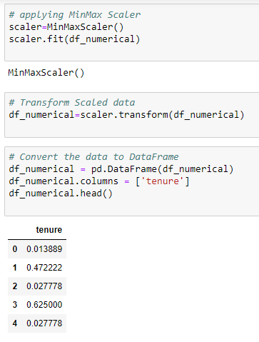

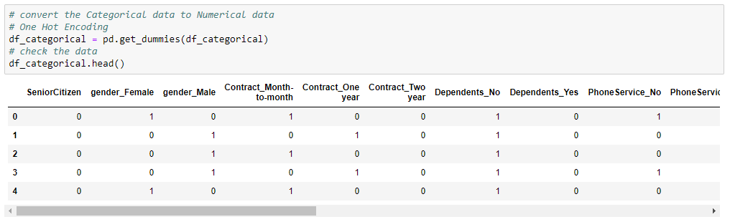

1. **Applied Dimension reduction method**

After converting categorical variables to numeric values, the number of input variables have increased.

Applied PCA method to reduce the number of variables to 5.

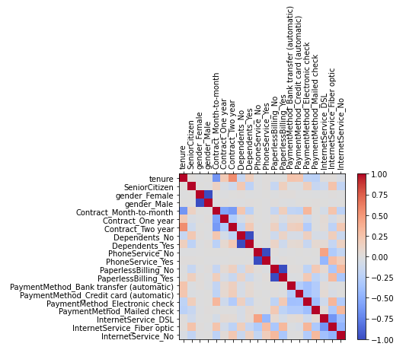

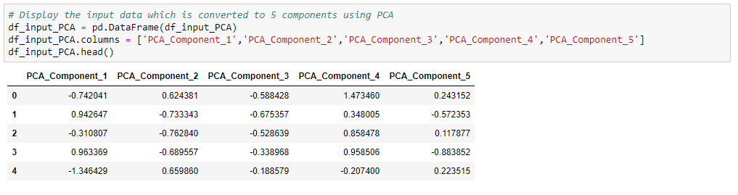

1. **Split the data in to Train and Test**

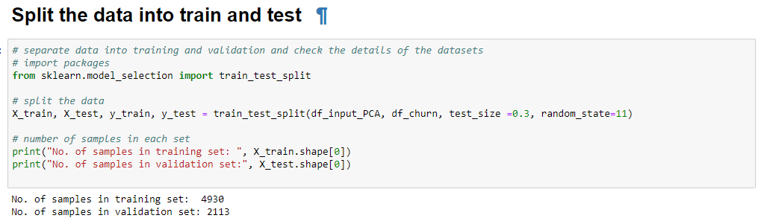

**Requirement Development:**

To Achieve the requirement, I used python as my primary tool to build charts and stats to get better understanding of the data. As a next step will use multiple supervised machine learning algorithms to build couple of models to pick the most efficient model.

**Model Development:**

Planning to build multiple models using Logistic Regression, Random Forest and AdaBoost Classifier, as part of the build and based on the accuracy of the confusion matrix.

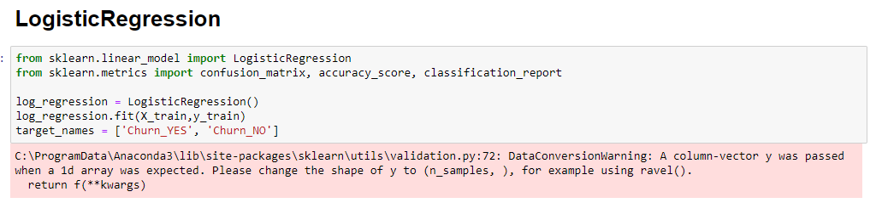

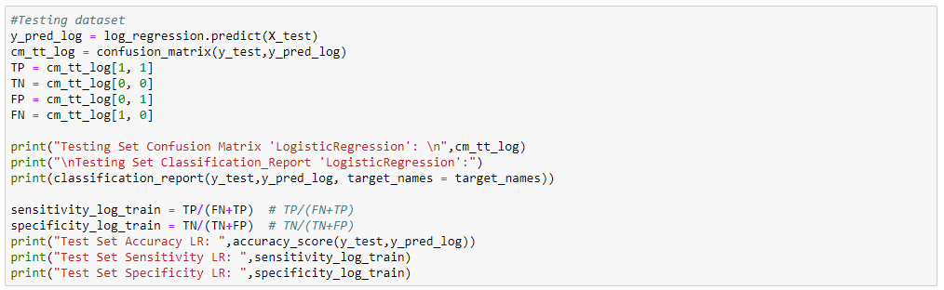

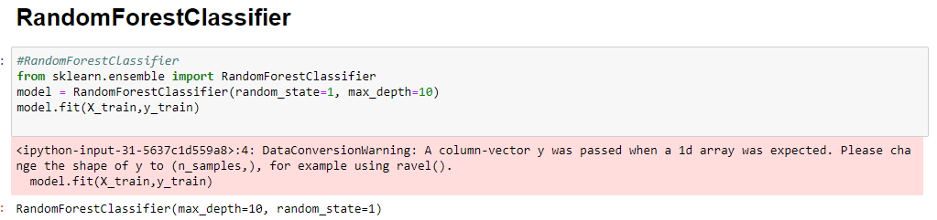

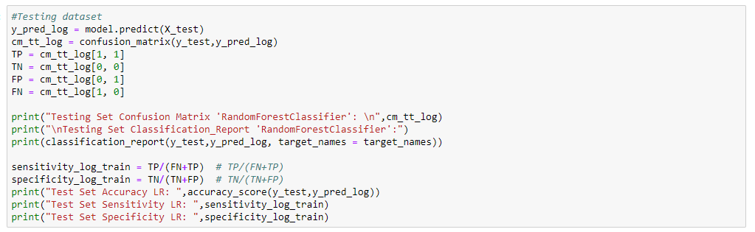

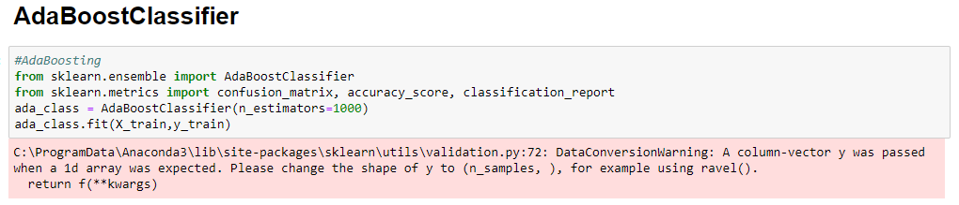

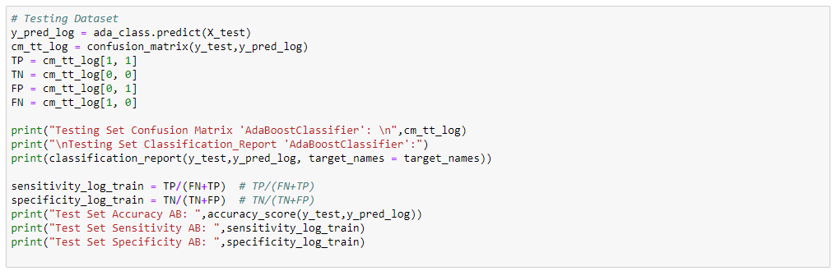

**Testing and Evaluation:**

While in the process of building the model, planning to split the data as 70% for building the model and 30% to evaluate the model. This gives us enough sample data to test in all the scenarios to make sure the model is accurate.



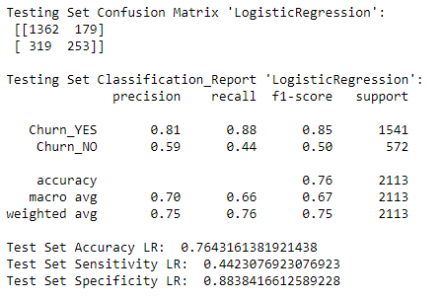



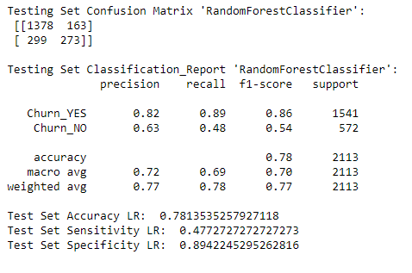



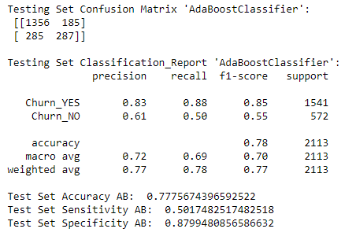

**Results**

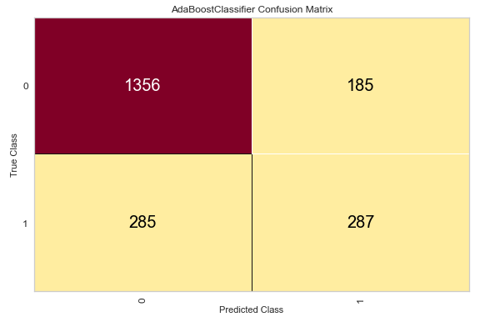

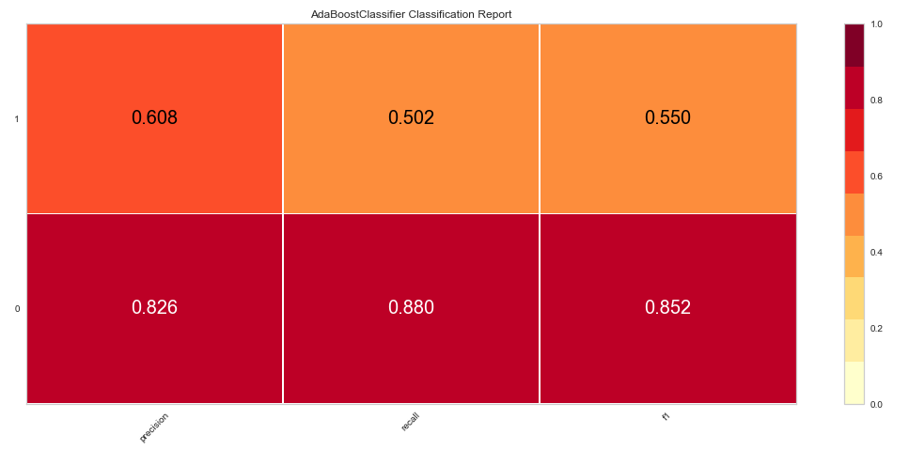

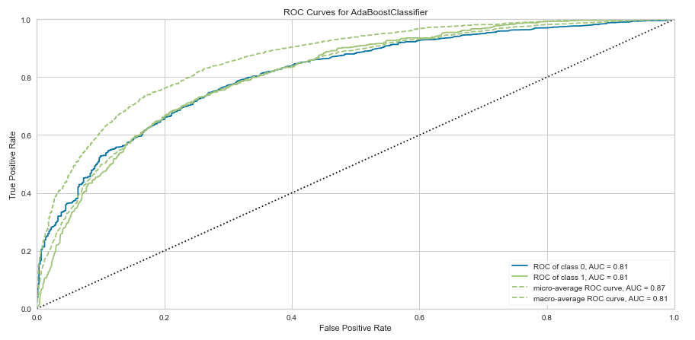

**Reference:**

[Telco Customer Churn | Kaggle](https://www.kaggle.com/blastchar/telco-customer-churn)

[How Costly Is Customer Churn in the Telecom Industry? - The European Business Review](https://www.europeanbusinessreview.com/how-costly-is-customer-churn-in-the-telecom-industry/?__cf_chl_jschl_tk__=ec58e0210ef4250a8414742b7aaa8d8e28384753-1611086044-0-AXu6Mldw8Cpmi6L6s5SgV1PXJkIGPIbNtM2k3mk8dG4GwrfiMZ4fT3rVf0CPVbws4ipH6NuFN2fITmeBiQb8uSJYkXQKBcXB-e3XBH6IJWYli7zOM4eqnO9BCh0JE11v9IHHQZeKKMNRTUecYHq5Mahj6uNBBJ23n_LWFAdEF677ZQEQpPYruho0OLOLbdjBj-oKjPGHAZ52v2QMgPAHjyXRIDb-FEUu_sFhz8CW6q0KxFhOgoPWW_R8KZhMo4AOUlv2fbzwIi3oYhYXMSMOdAjpE9u7gRwD-0RQeFCEtTEzQqRmjC2QEbIGAHZKgbkn99TTuu5kBJLOuOoRLFhaD9d-oHKuQ27yx7WrU_mDPxYdp7qkByeE3o25LzRg460JyA)